
WHITE PAPER
KEY LEARNINGS AND RECOMMENDATIONS
FOR TRANSFORMING GURGAON INTO A SMART CITY
CONFERENCE: Gurgaon as a Smart City
September 12, 2012, Palms, Sushant Lok-I, Gurgaon

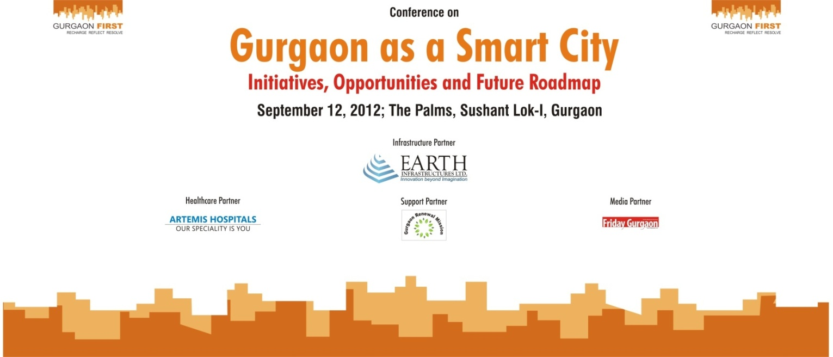
1.Better utilization of EDC collected for Gurgaon’s Development | More funds need to be allocated for Gurgaon’s development from Haryana’s kitty. Gurgaon contributes almost 50 per cent to the state exchequer, but it does not even get 20 per cent of it back to be utilized for its own good. We need development funds for Gurgaon’s roads, street lighting, improving traffic systems, revamping transmission and distribution of electricity and improving water distribution as well as for enhancing the greenery of the city.
2.Planning based on flawed population statistics – needs correction | Gurgaon is continuously being extended to more sectors, without the authorities acknowledging the fact that each new area or building will need additional resources. Such willy nilly extensions should stop, and whatever areas lie within Gurgaon should have proper resource planning and allocation. Currently, there is no reliable study that gives an accurate figure for Gurgaon’s population. As a result, requirement and projections for water, electricity demand etc. are also not accurate. In such a scenario, it is difficult to plan and forecast for future.
3.Multiple authorities lead to confusion inadequate governance | Gurgaon has multiple authorities (HUDA, MCG, PWD NHAI and some departments in Chandigarh etc) with overlapping roles. It is not clear as to who has the ownership of and accountability for Gurgaon. Clarity on what functions fall under what authority/agency should be laid out on the official websites of all authorities, agencies and government departments.
Institutional Capacity of HUDA and MCG needs to be strengthened | While Gurgaon has grown from a small town to a modern city, its institutions continue to operate with the old mindsets. Systems and processes need to be revamped. HUDA and MCG officers should go for upgradation of their knowledge of urban planning and development through regular training workshops and interact with other progressive city agencies. Besides, the role and ambit of the MCG needs to be strengthened especially now with the elected representatives such as the councillors under its umbrella. It’s a pity that most residents in New Gurgaon are not even aware of the existence of MCG.
Administrative Change at the Top: One Solution to Many Problems | Considering Gurgaon’s stature as a world class city with over 300 fortune 500 companies operating in the city with over 20 lakh population currently should ideally have an empowered political leadership such as a City Mayor akin to major cities in the world. Such a Mayor could be one-stop solution to all issues of Gurgaon and various departments could report into him as suggested by Ms Nisha Singh, Councillor, MCG. Unlike Noida, Gurgaon also does not have a Development Authority. Why should all crucial decisions for Gurgaon be taken in Chandigarh? Why should somebody based in Chandigarh/Panchkula be motivated to make crucial changes for Gurgaon? The old structures seem so irrational and out of sync with current realities.
Provision for Online Complaint Posting and Redressal by authorities | There should also be a provision for posting and monitoring complaints online on the official websites of the main authorities. (Dr Praveen Kumar, administrator, HUDA assured the house that such a provision will be set up on HUDA’s site within 15 days.)
Water Planning and Management is not an option but an urgent necessity | - A high powered advisory authority on water to plan and manage water resources and distribution systems should be created. An authentic study of what is the current population of Gurgaon and how much is the demand for water, along with projected growth figures needs to be carried out in the right earnest. There are all sorts of numbers floating around currently.  - Despite the court ruling, ground water is still being extracted. Stricter rules to prohibit extraction of ground water are needed.  - Pipeline network for water distribution is highly inadequate. Colonies such as Maple Heights are being provided water through borewells and not through pipeline from Basai Canal.  - Rainwater harvesting has to be encouraged more vigourously. It has to be made compulsory for government buildings, commercial complexes and multi-storey buildings. Rainwater units should be properly dug and maintained by the MCG. Due to lack of maintenance, 80 per cent of the pits become dysfunctional in the first year itself. Recycling of sewerage water is also a must to improve the level of ground water.  - Since Gurgaon does not have a natural source of water, artificial water bodies like ponds and lakes should be created.  - PPP projects in O&M as well as water treatment and sewerage should be encouraged to build capacity in each of these areas.
Let Gurgaon be a city that cares for Low Income Groups and the Underprivileged | - Low income groups of the city are crying for attention. They need affordable basic health care services, more hygienic living conditions and also low income housing options. Otherwise, slums and unauthorized colonies will continue to proliferate.  - City’s state-of-the art hospitals should cater to providing healthcare for the poor. Public Private Partnership models can address the issue of affordable health services for the masses. A model where government takes care of the basic health needs of the poor and private hospitals take care of the secondary and tertiary needs was proposed by Dr Devlina Chakravarty, COO, Artemis Hospitals. Besides, all private hospitals should be mandatorily asked to adopt rural areas and villages near Gurgaon by sending mobile health check up vans and setting up camps from time to time.  - Vocational training institutes, better schools as well as scholarships need to be provided for the underprivileged. NGOs can be involved in this drive.  - Builders need to be incentivized to construct low income housing projects as well.
Solar has a great future in Gurgaon; let’s go for it | - Gurgaon has a huge potential for solar PV and solar rooftops which needs to be encouraged. It has already been selected by the centre as one of the 20 solar cities of India. Under the programme, subsidy/funds would be provided to encourage use of solar. The city should make the most from such a scheme.  - There is a legislation that made it mandatory to adopt solar for heating water but most builders in the city have circumvented this policy. Unfortunately, the mandatory provision in the building bye-laws is only applicable to plot sizes of 500 sq yards and above. Such sized plots constitute less than 10% of the total residential plots hence a overwhelming proportion of the homes being constructed will fall outside the preview of this provision. To have a significant impact on electricity demand especially during winters the mandatory provision should apply to all plot sizes of 200 sq yards and above.  - Solar PC as well as LEDs can be used for traffic lights, street lights, blinkers on roads and parking lights.  - Solar power should be made compulsory for malls, housing societies, and commercial establishments. Malls are power guzzlers. Especially with the large amount of glass in their building structures, they trap a lot of heat. Through legislation, it should be mandatory for malls to have some solar structures to take care of atleast some part of their power requirement.  - Regular visits of RWAs should be arranged to Solar Energy Centre (Guwal Pahari) as well as Rajiv Gandhi Renewable Centre (at Leisure Valley) to improve awareness levels about use of solar and the fact that price of solar PV is reducing.  - Schools and Hospitals should be encouraged to have solar roof top panels. Solar power should be popularized among school students.
Parking Solutions Needed | - Inadequate Parking Space: Multi level parking at several strategic spots is the need of the hour. Private parties can be invited to construct these.  - Another issue is that high rise flats do not have provision for adequate parking within the complexes with the result that residents are forced to park their cars on the service lanes outside the complex. This is clogging the service lanes. The authorities reacted to this observation by saying that in the next phase of complexes, builders will be asked to leave the ground floor of the building entirely for parking.
Electricity sector plagued with high cost and poor quality: Private Participation needed sooner than later | - DHBVNL, the company that supplies electricity to Gurgaon, has failed miserably in providing reliable power to Gurgaon. Close by in Delhi, not only are the electricity rates less, there is more reliability of supply. Gurgaon’s industrial power rates are one of the highest in the country. A complete revamp of the system is called for.  - One of the solutions is to privatise distribution of electricity. However, due to lack of political willingness as well as mixed results of privatisation elsewhere, this may not be possible. So private franchisee (like in the case of Bhiwandi city in Maharashtra) could be appointed.  - Given Gurgaon’srapid surge in population, its share of bulk power should also be increased so that no load shedding is required.  - Till such time private franchisee is not appointed, a complete overhaul of transmission and distribution system, increasing the supply base to Gurgaon and complete metering has to be undertaken. There are central schemes that fund specific projects such as metering etc.
Traffic Problems Galore: Need cost effective solutions first | - One of the basic problems is that traffic and transportation in the city is under the purview of various agencies such as HUDA, MCG, PWD and NHAI. One central apex agency which coordinates between all the stakeholders, conducts research, employs traffic engineers, scouts for technology and gives consultancy is the need of the hour.  - More than road widening, what is needed on a priority basis is declogging key junctions such as IFFCO Chowk, Hero Honda Chowk, Huda City Centre and Shankar Chowk. This can be done at minimal investments. RITES has offered to give free consultancy to decongest key traffic junctions of Gurgaon.  - Structures like foot-overbridges, underpasses and flyovers also help in traffic decongestion. They reduce accidents and help save lives. HUDA has in principle agreed to make underpasses at Rajiv Chowk, IFFCO Chowk and South City. When will these be taken up, is the question.  - Gurgaon should be a pedestrian friendly city. The Mall Road (MG Road) should be made into a showcase walking road.  - The speed on roads is directly proportional to the quality of roads. So road maintenance has to be taken up in the right earnest. Potholes should be dealt with.  - Lack of Service Lanes: Many areas of Gurgaon badly need a service lane to improve accessibility and avoid traffic criss-cross. Such areas need to be prioritized and service lanes built immediately.  - Finally, the field strength of traffic cops has to be increased seeing the increase in vehicular traffic in the city.

